Отправка **корзины** (только **name, price**) на **email администратора (ajax-Guzzle)**.

1.**cart.blade.php**

<div class="box-footer">

<button type="button" class="btn btn-danger button_clearcart">Clear Cart</button>

<form name="form_clearcart" method="post" action="{{ route('clearcart') }}" style="display: none;">

{{ csrf_field() }}

</form>

**<button type="button" class="btn btn-primary button_order">To Order</button>**

**</div>**

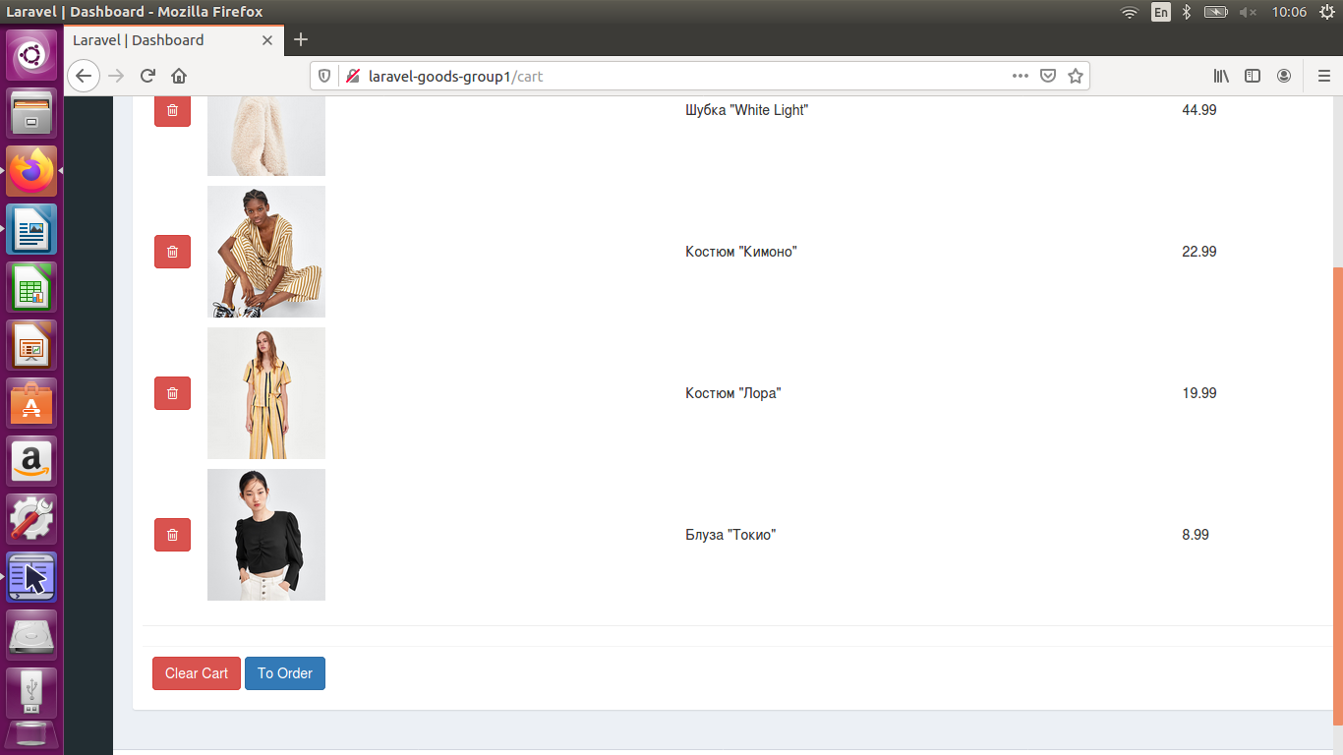

2.**config\app.php**

...

],

**'adminemail' => 'kan1001@mail.ru',**

];

(доступ из кода **config('app.adminemail')**)

+cd www/laravel-goods-group1

**php artisan config:clear**

3.**composer.json**

...

"require": {

"php": "^7.1.3",

"fideloper/proxy": "^4.0",

"laravel/framework": "5.8.*",

"laravel/tinker": "^1.0"**,**

**"guzzlehttp/guzzle": "^6.3"**

},

…

+**composer update**

4.**brick-standard.blade.php**

...

<td **class="cart_name"**>{{ $good->name }}</td>

<td **class="cart_price"**>{{ $good->price }}</td>

</tr>

5.**cart.blade.php**

...

**$('.button_order').click(function(){**

**BaseRecord.order(document.getElementById('pannel'));**

**});**

});

6.**main.js**

**order**: function(**pannel**){

**var arr_cart_name=pannel.getElementsByClassName('cart_name');**

**var arr_cart_price=pannel.getElementsByClassName('cart_price');**

**var content_order='Your order<br>';**

**for(var i=0; i<arr_cart_name.length; ++i){**

**content_order+=arr_cart_name[i].innerHTML+'<br>'+arr_cart_price[i].innerHTML+'<br><br>';**

**}**

//$('#pannel').html(content_order);

var ajaxSetting={

**method: 'post',**

**url: '/toorder',**

**data: {**

**content: content_order,**

**},**

success: function(data){

**alert(data.answer);**

},

};

$.ajax(ajaxSetting);

},

7.**GoodController.php**

/**

* Mailer order.

*

* @return \Illuminate\Contracts\Support\Renderable

*/

public function **toorder(Request $request)**

**{**

**return $this->repository->orderMailer($request->content);**

}

8.**GoodRepository.php**

/**

* Mailer order.

*

* @return \Illuminate\Contracts\Support\Renderable

*/

public function **orderMailer($content)**

{

**$title = 'Order from shop.com' . date('d-m-Y H:i:s');**

**$client = new \GuzzleHttp\Client**([

'headers' => [

//'Authorization' => '9267585bb333341dc049321d4e74398f',

//'Content-Type' => 'application/json',

]

]);

$response = $client->request(**'GET', 'http://api.25one.com.ua/api_mail.php?email_to=' . config('app.adminemail') . '&title=' . $title . '&message=' . $content**,

[

//...

]);

//return json_decode($response->getBody()->getContents());

**return response()->json([**

**'answer' => $response->getBody()->getContents(),**

**]);**

}

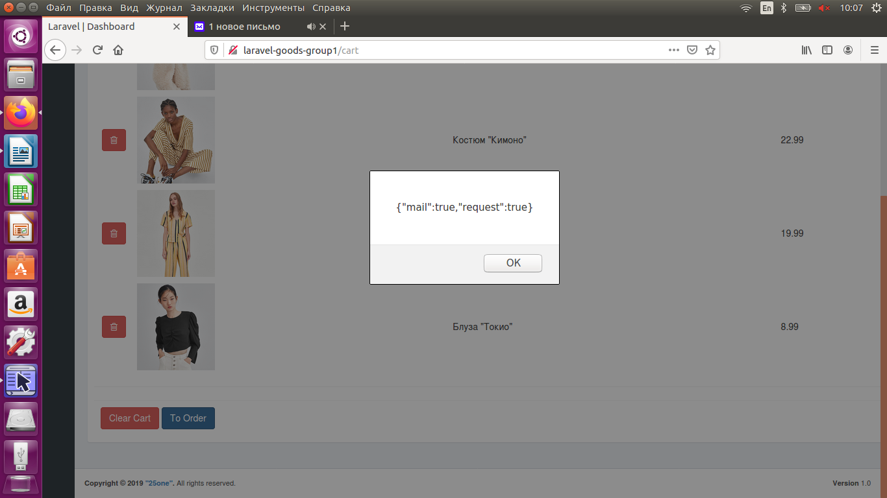

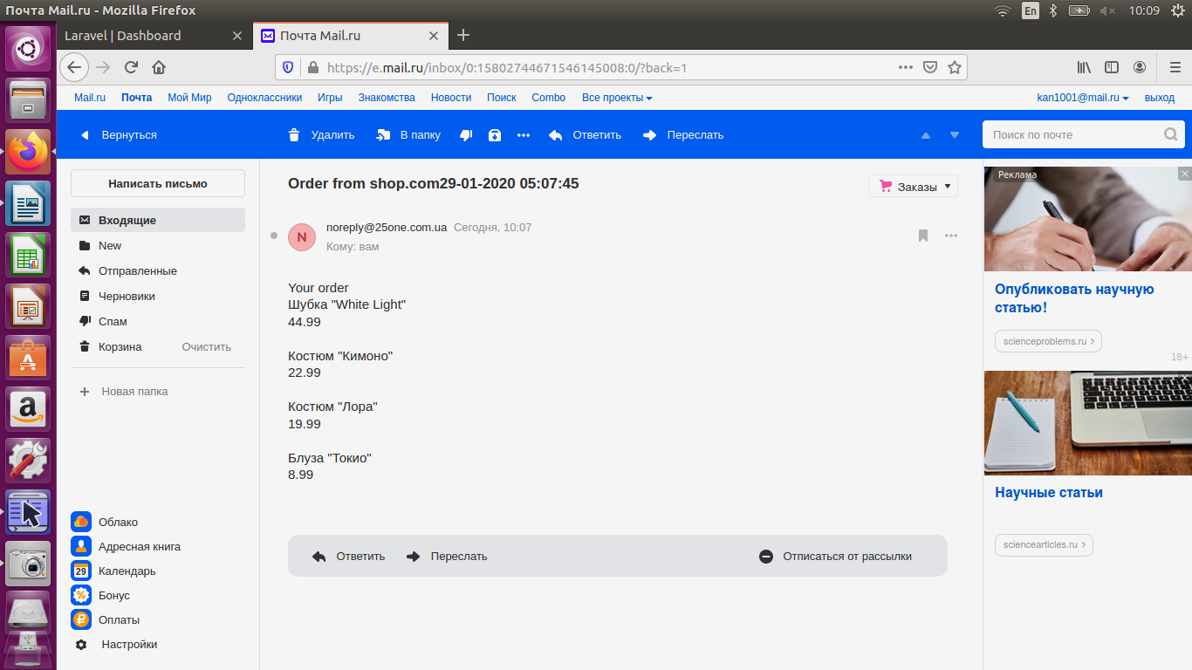

-**mine.js**

success: function(data){

**//**alert(data.answer);

**var data_json=JSON.parse(data.answer);**

**if(data_json['mail']) {**

**alert('Your order has been sendes...');**

**}**

},